Lab Report #6

Hanz Chua U26738740

Viraj Amarasinghe U14806439

Jian Gong U42910460

Introduction

In this lab, we design a game show circuit that determines which contestant presses their button first. The purpose of this lab was to introduce us to sequential circuits and to teach us how to use function generators for clocks. It helps us gain a deeper understanding of sequential circuit design.

Methods and Materials

1 74LS08 2-Input AND Gate

1 74LS32N 2-Input OR Gate

1 74LS109N Dual JK Flip-Flop

2 LEDs

2 Resistors

3 Push Button

1. After considering the behavior of the game show circuit and observing the information given to us on half of the circuit, we found Q1*’s equation, state transition diagram, and K-map. This information aided us in designing the game show circuit.
2. We began implementing the circuit using our breadboard, and 3 gate IC’s. We connected the wires to their corresponding gates to match the schematic we designed.
3. To test if our circuit was working, we would press a button, check the light associated with it, and then press the other button. We would then press the reset button and repeat the same step with the other button.

Result

We observed that the game show circuit worked as planned; the first contestant who presses the button, has their corresponding LED light up and no other input is accepted. We also observed that the circuit remains in that state until the reset button is pressed. After resolving some issues/mistakes, we concluded that th results came out as expected and contributed to the goal of the experiment; to help us gain a deeper understanding of sequential circuit design.

Conclusion

In conclusion, we designed a game show circuit that lights up someones LED and accepts no other input. Issues we ran into were omitting resistors and mistakenly plugging in wires to wrong holes.

Questions

| Q1* |  | x1x0 | | | |
| --- | --- | --- | --- | --- | --- |
|  |  | 00 | 01 | 11 | 10 |
| Q1Q0 | 00 | 0 | 0 | 1 | 1 |
| 01 | 0 | 0 | 0 | 0 |
| 11 | 1 | 1 | 1 | 1 |
| 10 | 1 | 1 | 1 | 1 |

Q1*= Q1 + Q0’X1

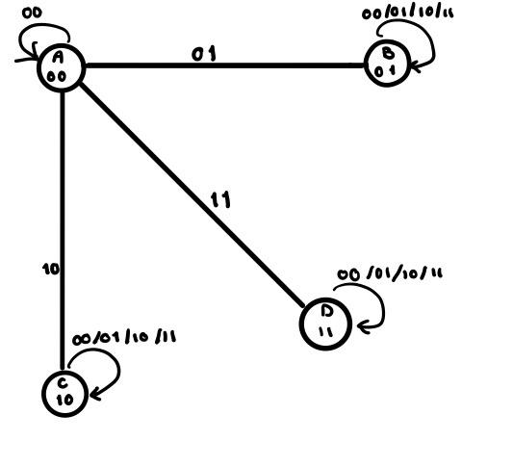

1. 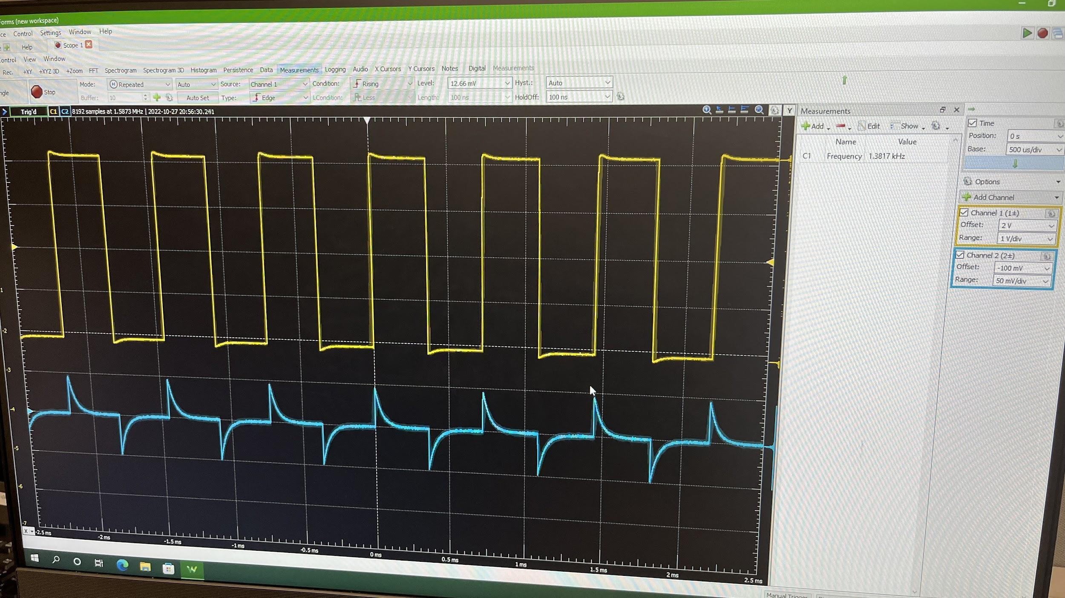
2. The circuit has two inputs(push buttons), one for each contestant. These inputs are associated with an output(LEDs). The circuit starts in a wait state, where both inputs are 0 and the LEDs are off. Whichever contestant presses the button first has their associated LED light up, and the circuit no longer accepts further inputs. The circuit remains in this state until the reset push button is pressed, which returns the circuit into the wait state.